Task 4: To create navbar like this.

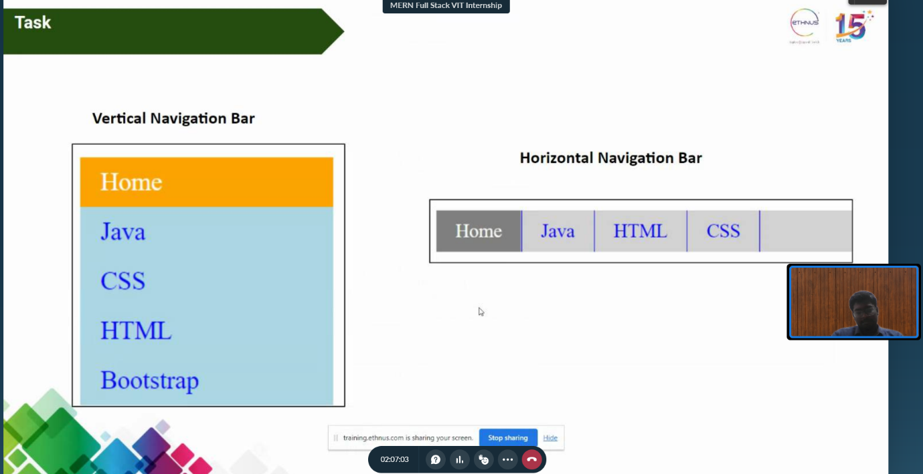

HTML code:

<html lang="en">

  <head>

    <link rel="stylesheet" href="navbar.css" />

    <meta charset="UTF-8" />

    <meta http-equiv="X-UA-Compatible" content="IE=edge" />

    <meta name="viewport" content="width=device-width, initial-scale=1.0" />

    <title>Navbar</title>

  </head>

  <body>

    <br />Navbar - 20BCE2096 <br /><br /><br />

    <div class="container">

      <div class="vnavbar">

        <ul>

          <h2>Vertical Navbar</h2>

          <li><a href="#">Home</a></li>

          <li><a href="#">Java</a></li>

          <li><a href="#">CSS</a></li>

          <li><a href="#">HTML</a></li>

          <li><a href="#">Bootstrap</a></li>

        </ul>

      </div>

      <div class="hnavbar">

        <h2>Horizontal Navbar</h2>

        <ul>

          <li><a href="#">Home</a></li>

          <li><a href="#">Java</a></li>

          <li><a href="#">CSS</a></li>

          <li><a href="#">HTML</a></li>

        </ul>

      </div>

    </div>

  </body>

</html>

CSS code:

\* {

  box-sizing: border-box;

}

.container {

  display: flex;

  margin: 0px;

  height: 400px;

  justify-content: center;

  align-items: flex-start;

}

.vnavbar {

  flex: 1;

  padding: 1rem;

  display: flex;

  flex-direction: column;

  justify-content: center;

  align-items: center;

  list-style-type: none;

}

.hnavbar {

  flex: 3;

  margin: 0.5rem 0rem;

  list-style-type: none;

  padding: 1rem;

  display: flex;

  flex-direction: column;

}

.vnavbar ul {

  list-style-type: none;

  padding: 0;

  margin: 0;

  display: flex;

  flex-direction: column;

}

.hnavbar ul {

  list-style-type: none;

  padding: 0;

  margin: 0;

  display: flex;

  flex-direction: row;

}

.vnavbar li,

.hnavbar li {

  margin: none;

  padding: 4;

  background-color: aqua;

}

.hnavbar li {

  background-color: lightgrey;

}

.hnavbar li:first-child {

  border-right: 1px solid blue;

}

.hnavbar li:last-child {

  border-left: 1px solid blue;

}

.hnavbar li {

  border-left: 1px solid blue;

  border-right: 1px solid blue;

}

.vnavbar a,

.hnavbar a {

  display: block;

  text-decoration: none;

  color: #333333;

  padding: 5px;

  color: blue;

  transition: color 0.3s;

}

.vnavbar a:hover,

.vnavbar li:hover,

.hnavbar a:hover,

.hnavbar li:hover {

  color: white;

  background-color: orange;

}

Output:

